Faculty Resources:

Offer resources for educators, including teaching materials, lesson plans, and assessment tools.

Feature articles on effective teaching methods and innovations in education.

Link to educational platforms for instructors.

External Link: Dental Faculty Resources

<https://dental.pacific.edu/dental/faculty-and-research/resources>



**Teaching Materials, Lesson Plans, and Assessment Tools:**

Teaching Materials: Curate a diverse collection of teaching materials, including lecture slides, case studies, and multimedia resources. Ensure that materials cater to different learning styles and cover fundamental to advanced topics in dental education.

**Lesson Plans:**

Develop detailed lesson plans that incorporate active learning strategies, practical demonstrations, and opportunities for engagement. Include objectives, timelines, and suggested assessment methods.

**Assessment Tools:**

Provide a variety of assessment tools, such as quizzes, exams, and practical evaluations. Offer guidance on aligning assessments with learning objectives and promoting fair and constructive feedback.

External Link: [ADEA - Resources for Dental Educators](https://www.adea.org/GoDental/Educator-Resources)

<https://www.adea.org/cadpd/allied-dental-education-resources.aspx>

**Articles on Effective Teaching Methods and Innovations:**

Explore articles that delve into evidence-based teaching methods, including case-based learning, problem-solving approaches, and the integration of technology in dental education.

Innovative practices, such as virtual reality simulations, flipped classrooms, and interdisciplinary collaborations. Showcase how these innovations enhance the learning experience.

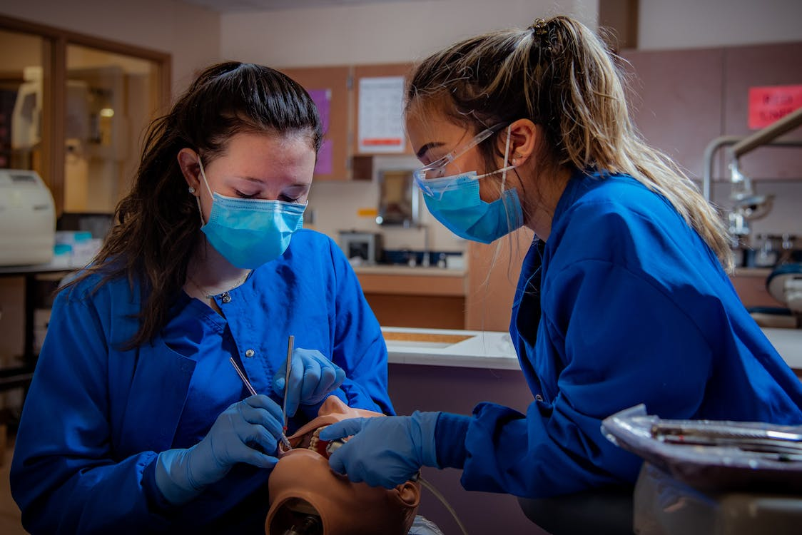

External Links:

[Impact](https://www.jdentaled.org/content/early/recent) of Artificial intelligence on Dental Education

<https://www.mdpi.com/2227-7102/13/2/150>

Teaching Dentistry to Generation Z Learners Using an Autonomous Smart Learning Environment

<https://www.igi-global.com/chapter/dental-education-in-the-information-age/320383>

Mental Disorders and Oral Diseases: Future Research Directions

<https://journals.sagepub.com/doi/abs/10.1177/00220345221120510>

**Link to Educational Platforms for Instructors:**

**Virtual Simulation Tools:**

Virtual patient simulation platforms, allowing instructors to enhance clinical education in a risk-free virtual environment.

External Link:

<https://www.healthysimulation.com/dental-simulation/>

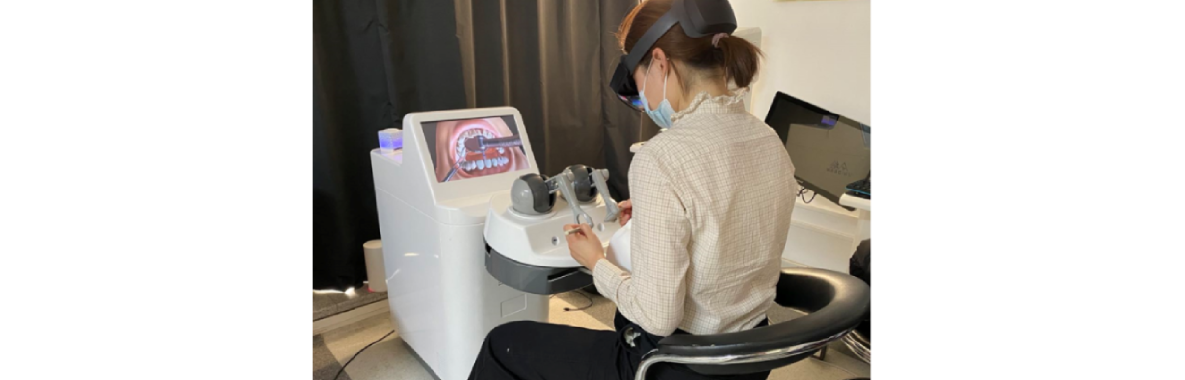

**Online Assessment Platforms:**

Recommend platforms that facilitate easy creation, delivery, and grading of assessments, fostering efficient and timely feedback to dental professionals students.

External Link: [Online Learning for Dental Professionals](https://www.dentalcare.com/en-us/education)

<https://cpd.dentistry.co.uk/>



**Interactive Workshops and Webinars:**

Pedagogical Strategies: Offer workshops focusing on pedagogical strategies tailored to dental education, covering topics such as active learning techniques, curriculum development, and fostering critical thinking skills.

Technological Advancements: Explore webinars that showcase the latest technological advancements in dental education, including the use of augmented reality, artificial intelligence, and online learning platforms.

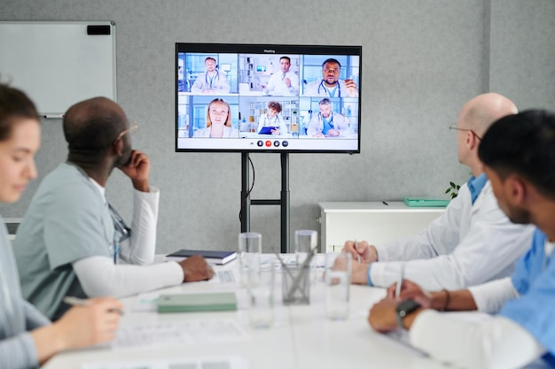 Example Link: Academy for Academic Leadership - Dental Education Events

Community Forums for Educators:

<https://www.adea.org/education/>